FEELINGS about THE PHOTOS BELOW
This one makes me feel happy and at home
This one makes me fell thirsty and hungry and in unknown location
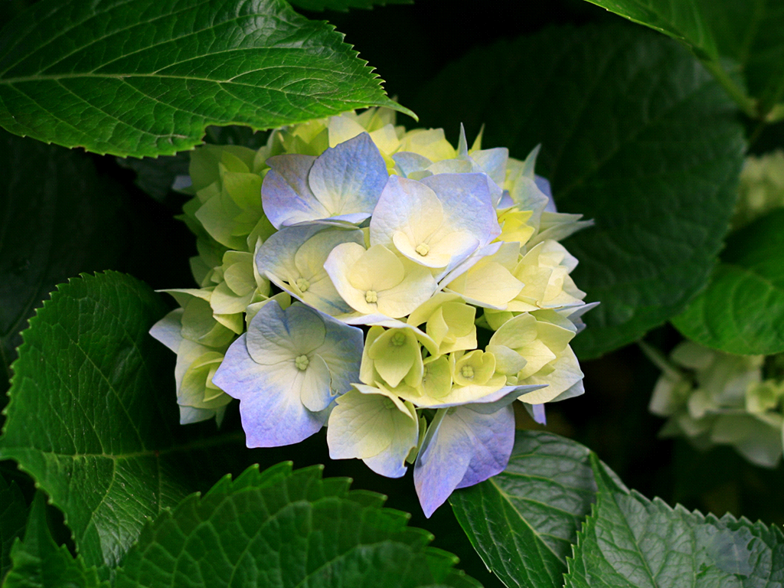
This one makes me feel Okay and that nothing is wrong
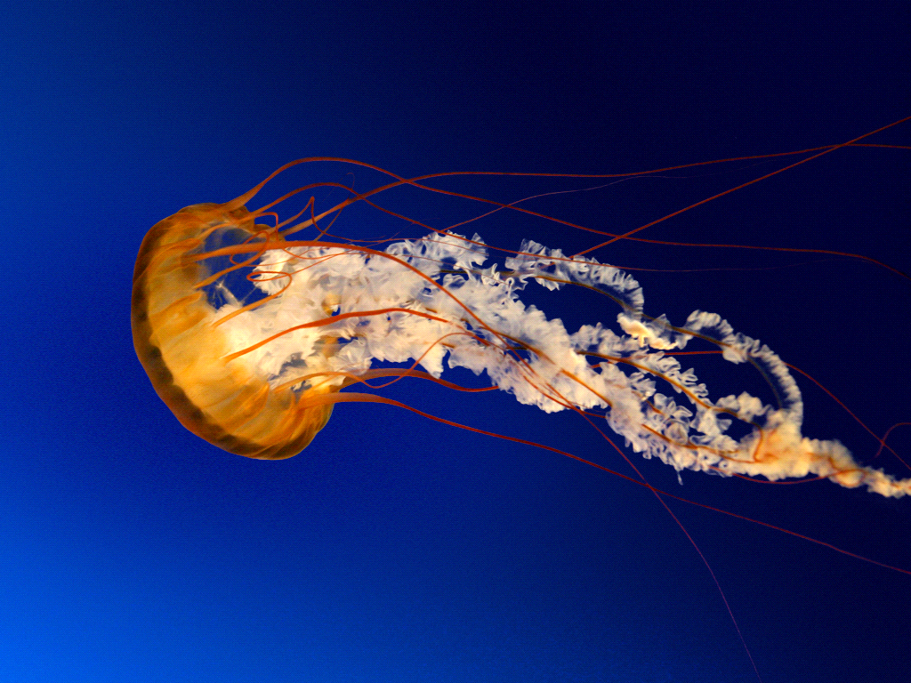
This one makes me feel aware of the surroundings and always look out for your friends and family
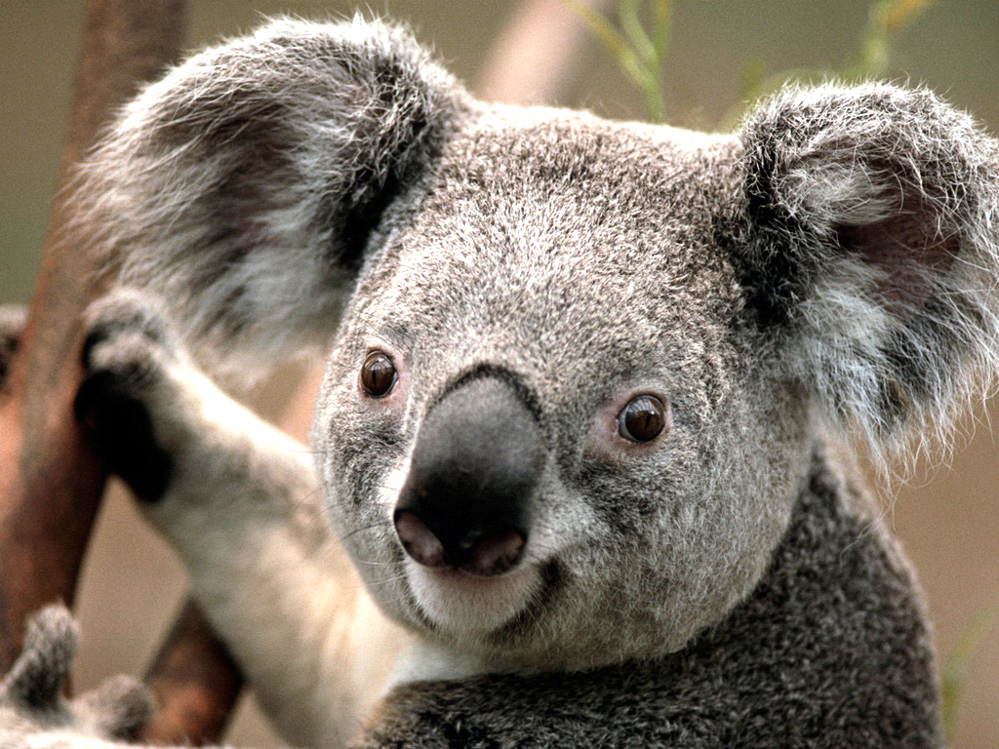
This one makes me feel alert and friendly plus never ever give up
This one makes me feel like nothing can stop me from walking on those rocks
NOW THIS I LIKE THE MOST IT MAKES ME FEAL I HAVE FAMILY AND FREANDS WATCHING OUT FOR ME
Now this one makes me feel heathy, happy, and joyful and that I am the light
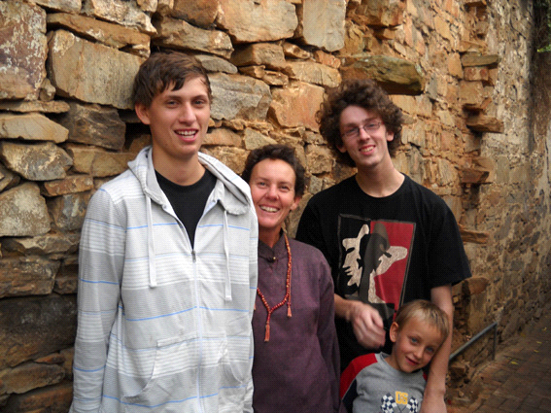
THIS IS MY FAMILY. NOW THE LITTLE ONE ON THE RIGHT IS ME, but I AM 11 NOW AND THEN I WAS 4 OR 5. THE MIDDLE ONE IS MY MUM AND THE OTHER ON THE RIGHT WITH HIS ARM ON MY SHOLDER IS DYLAN HE IS THE OLDEST AND HE IS MY BROTHER, THE ONE ON THE LEFT NEXT TO MY MUM IS JETHRO, HE IS ALSO MY BROTHER. WOW NOW I CALL THIS FAMILY AND THE Good TIMES!!! I ALMOST FORGOT I HAVE ANOTHER BROTHER FROM ANOTHER MOTHER HIS NAME IS MATTHEW COLLIN. WE ALSO HAVE GOOD TIMES WHEM WE SEE EACH OTHER, HE IS THE TYPE OF GUY WHO NEVER GIVES UP ON A JOB HE CAN’T DO LIKE BUILDING PLANES AND STUFF. NOW FOR ANOTHER IMPORTINT SOUL WHO WAS MY BEST COMPANION, HIS NAME CHANDER JOT HE AND I WERE LIKE NOTHING COULD STOP US AND THAT IF ONE OF US GOT INTO TROUBBLE WE WOULD TAKE EACH OTHERS BLAMES EVEN THOUGH A DOG CAN’T TALK DOESN’T MEAN HE CAN’T KNOW WHAT YOU ARE SAYING SO ALWAYS TRUST YOUR DOG ‘CUS ONCE I REMEMBER HE KEPT PULLING ME TO TRY SHOW ME SOMETHING AFTER A COUPLE OF MINUTS I DECIDED TO GO WITH AND HE SHOWED ME THAT HE HAD BROKEN SOMETHING SO I CLEANED IT THEN I REALISED THAT HE JUST SHOWED ME SOMETHING THAT BROKE. SO NOW I ALWAYS BELIVE AND TRUST A DOG. BUT AS EVERYONE KNOWS ALREADY, CHANDER JOT GOT HIT BY A BIG SUV AND WAS DRIVEN OVER TWICE AND THEN WE TOOK HIM TO THE VET HE SEEMED FINE SO MY MOM MAYA WENT AWAY AND SHORTLY I DID TOO AND ON THUSDAY HE WHENT TO THE VET WITH A FRIEND OF MY MOM’S HIS NAME IS BERT. BERT TOOK CHANDER JOT TO THE VET ON THUSDAY BECAUSE HE WAS’NT EATING OR ANYTHING SO WHEN HE HAD AN X-RAY THEY SAW HIS BONES WERE BROKEN and that one bone cut his bladder so all the wee went into his body making it toxic, so the vet in Port Alfred had to put him down and HE WILL BE BURRIED AT THE SPCA IN PORT ALFRED.
THIS MESSAGE IS FOR THE SOUL OF CHANDER JOT:
CHANDER, I NOW YOU DON’T READ FACEBOOK BUT I KNOW YOU NOW WHAT I AM SAYING, I LOVE YOU MY BOY I AM CERTAIN NOW THAT GOD OR SOMEONE ELSE NEEDS YOU MORE THAN WE DO SO THAT IS WHY YOU RAN IN FRONT OF THE CAR. I HOPE YOU ARE AT REST CHANDER JOT AND MOM JUST RELISED SOMTHING YETERDAY IT IS THAT MY FIRST TO INITIALS CJ AND YOURS ARE THE SAME SO I GUESS I WAS MEANT TO SEE YOU LOVE MOM AND YOUR MASTER CHRIS
